Multi-domain IMS - Group 7

Yuri Kolesnikov, Nishant Karajgikar, Nikhil Khatu

Professor Perros

**Introduction**

By setting up the logical network portrayed in the figure below we can simulate relationships between IMS cores and clients located on two separate domains. Screen shots of packet captures are taken during User Agent registration and the SIP session.

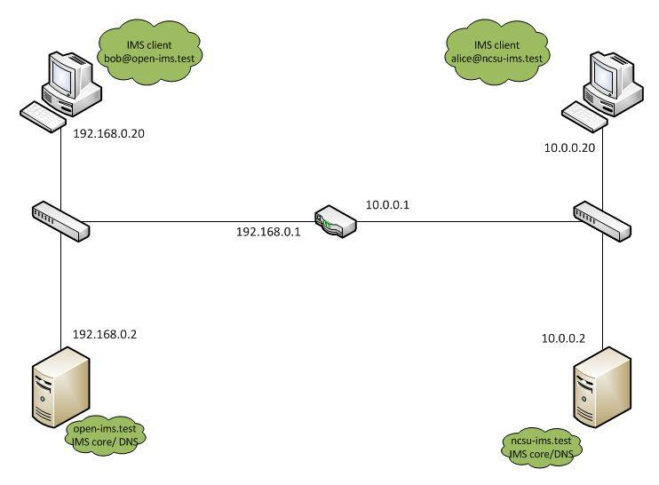

The screenshots below depict clients alice and bob registering with their respective IMS core network.

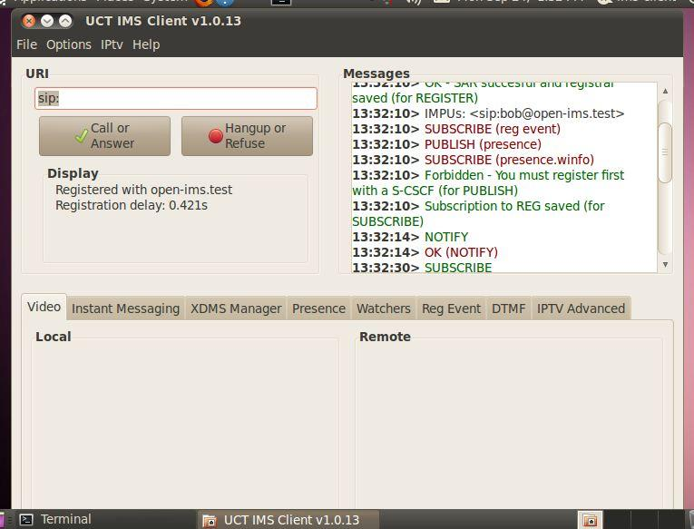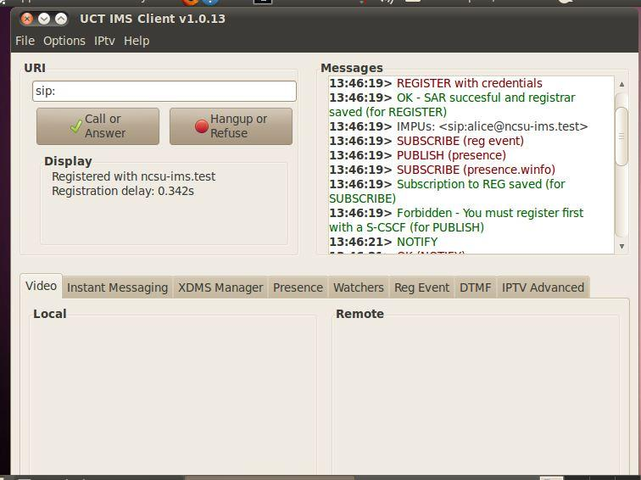

After the session setup signalling one can observe in two different vmware client windows; the client applications running on both bob and alice have messaging, voice, and video capability.

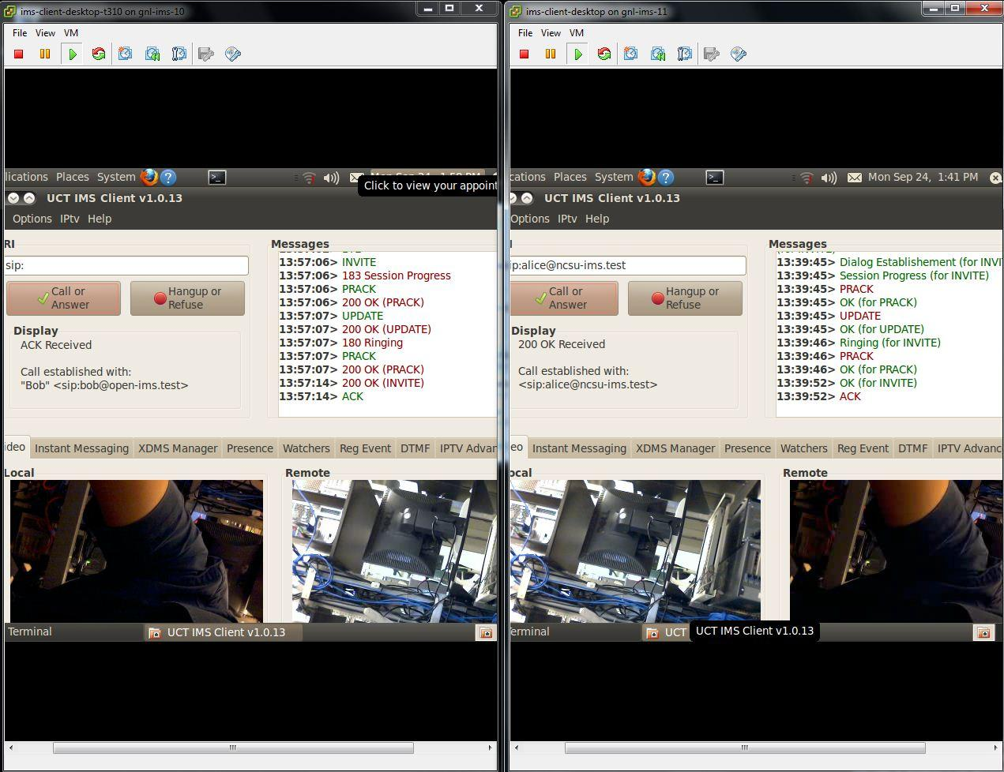

**1. In one of the clients observe a SIP/XML NOTIFY message, what is the value in the aor field in the xml part of the message, give screen shots.**

Value in aor field: sip:alice@ncsu-ims.test

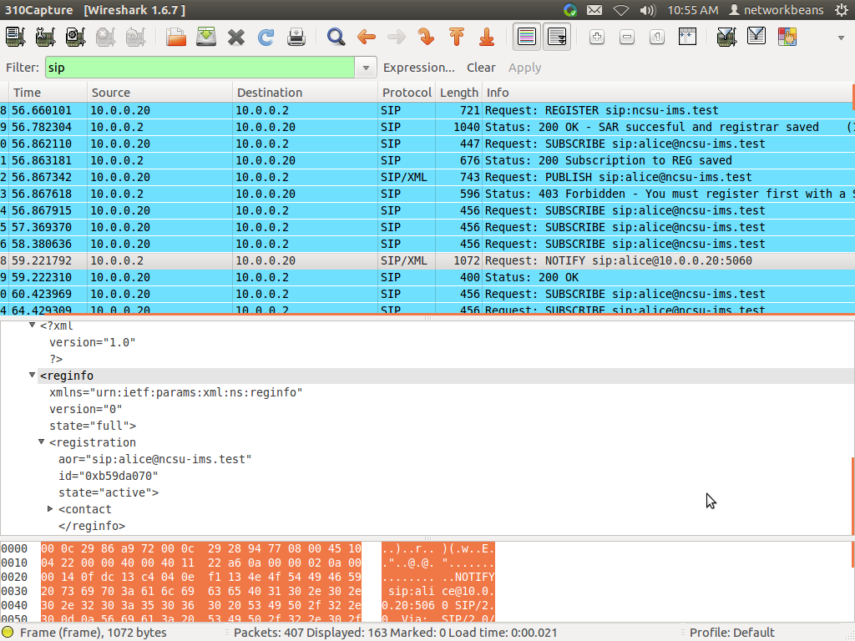

**2. In one of the servers observe the SIP/SDP Invite message and find**

**2a) From and To values**

From Value: sip:bob@open-ims.test

To Value: <sip:alice@ncsu-ims.test>

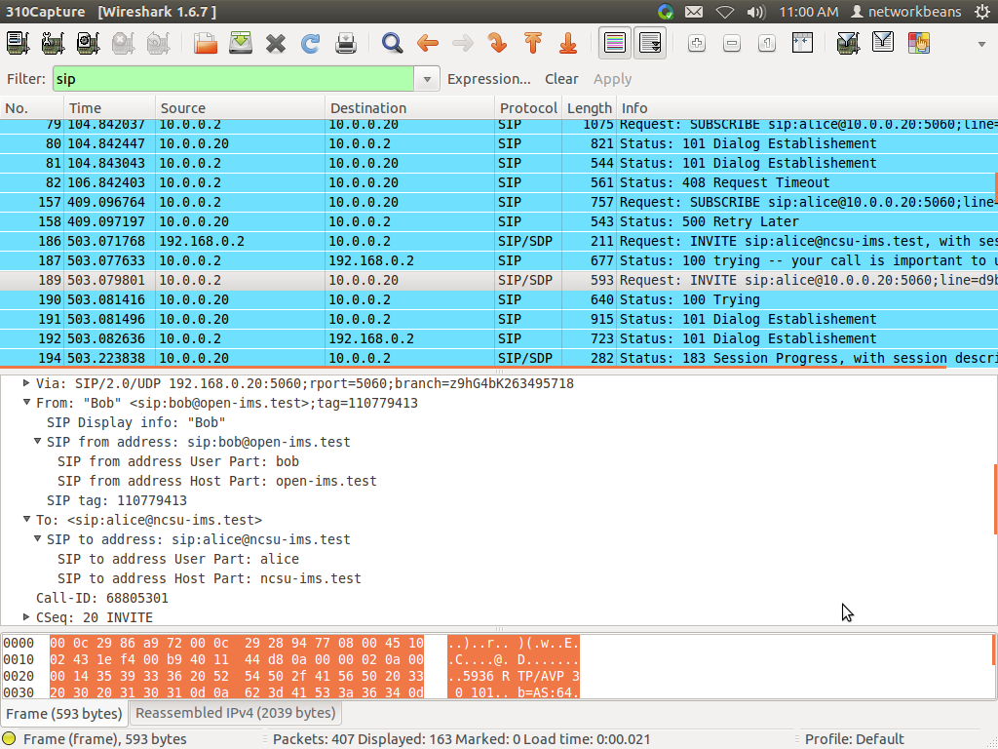

**(b) Connection Network Type**

Connection Network Type: IN

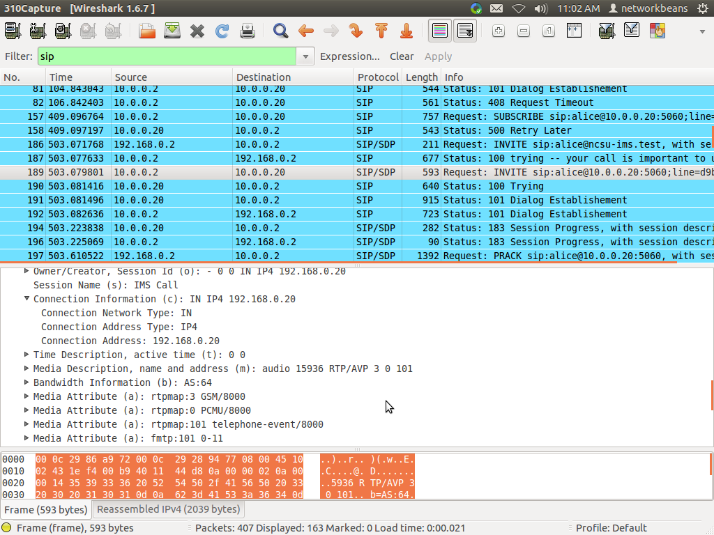

**(2c & 2d) Address and Address Type?**

Address: 192.168.0.20

Address Type: IP4

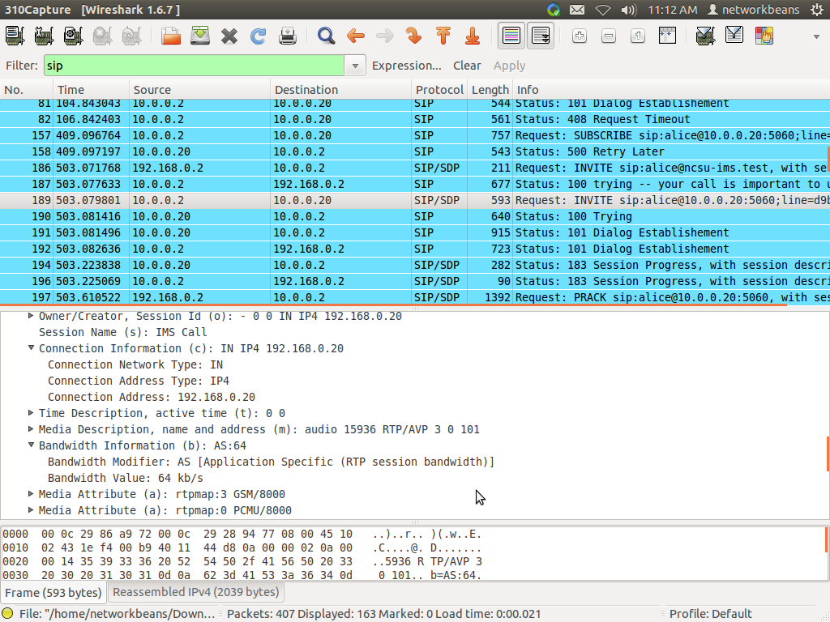

**(2e) What is the Bandwidth Value?**

Bandwidth value : 64kb/s

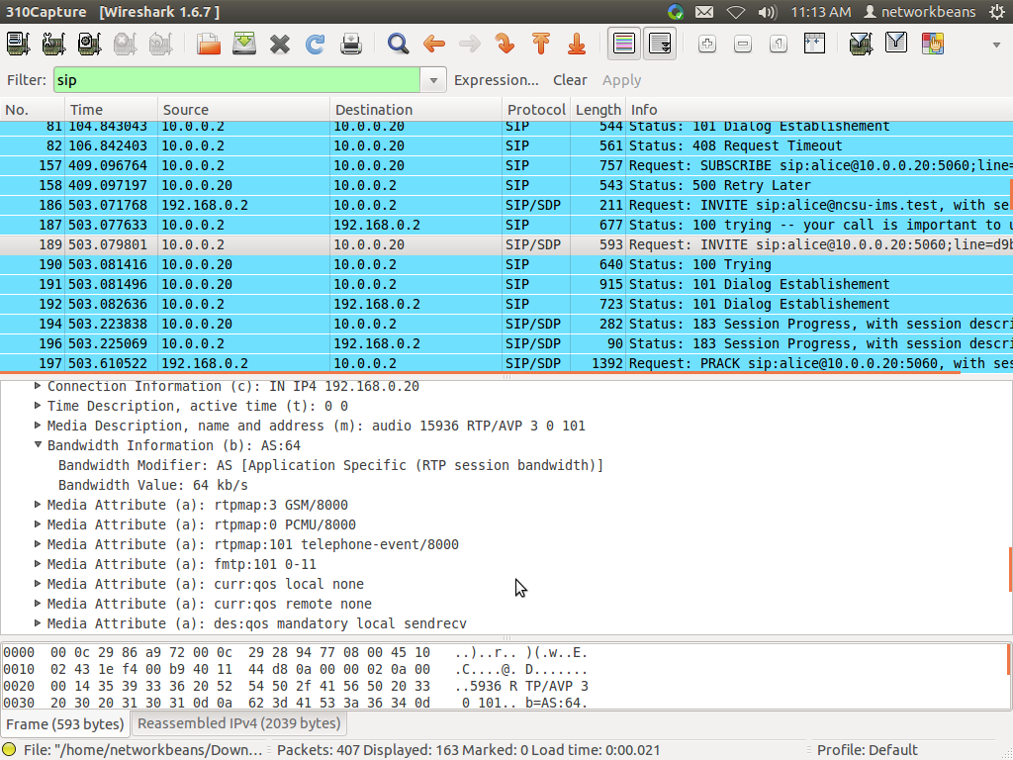

**(2f) What are the different MIME TYPES and their sampling rate?**

MIME types are:

1) GSM = 8000

2) PCMU - Sample rate = 8000

3) telephone-event - Sample rate = 8000

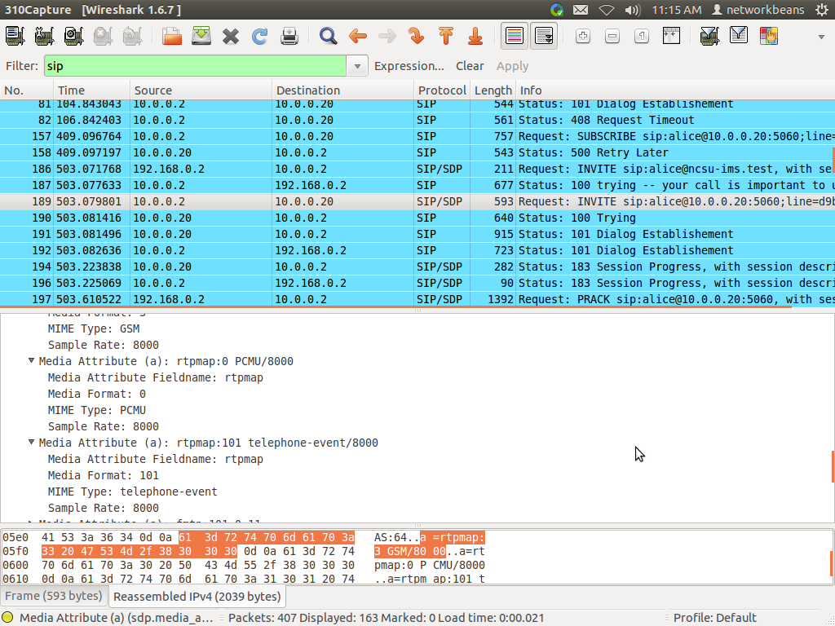

3. **Observe the PRACK message and answer the following**

**(3a) What is the difference between PRACK and ACK messages ?**

PRACK stands for Provisional Acknowledgement. These indicate reception of 1xx responses while the ACK indicates receipt of 2xx responses.

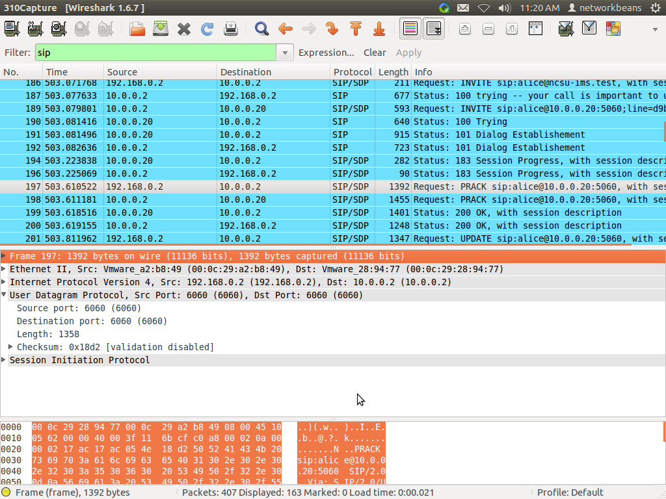

**(3b) What is the value of the Max-Forwards what does it signify?**

Max Forwards: 15

The Max-Forwards values signifies the valid number of hops a request can transit before it is rejected.

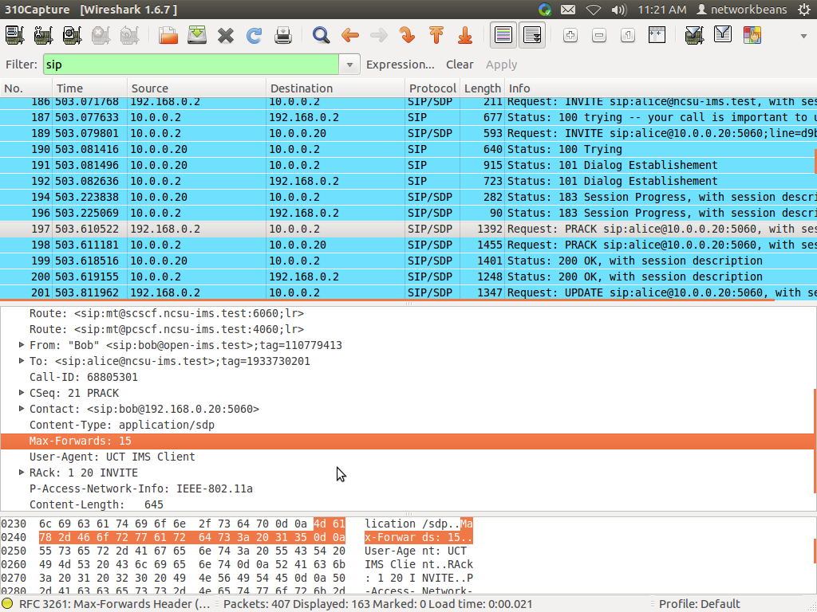

**(3c) What are the values for Media Description?**

Media type: message

Media Port: 13180

Media typs: video

Media Port: 25224

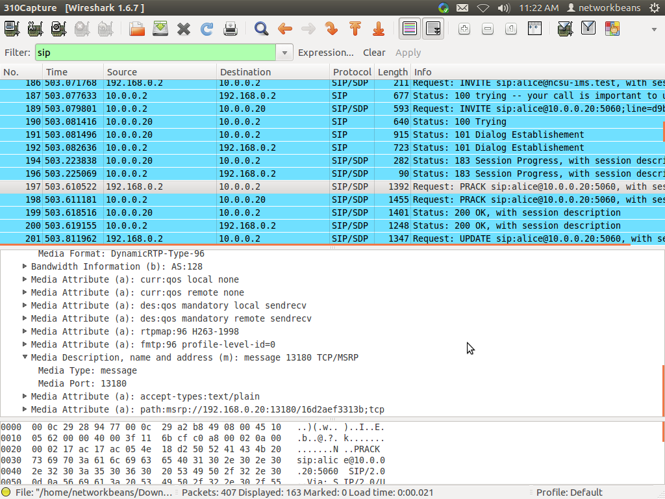

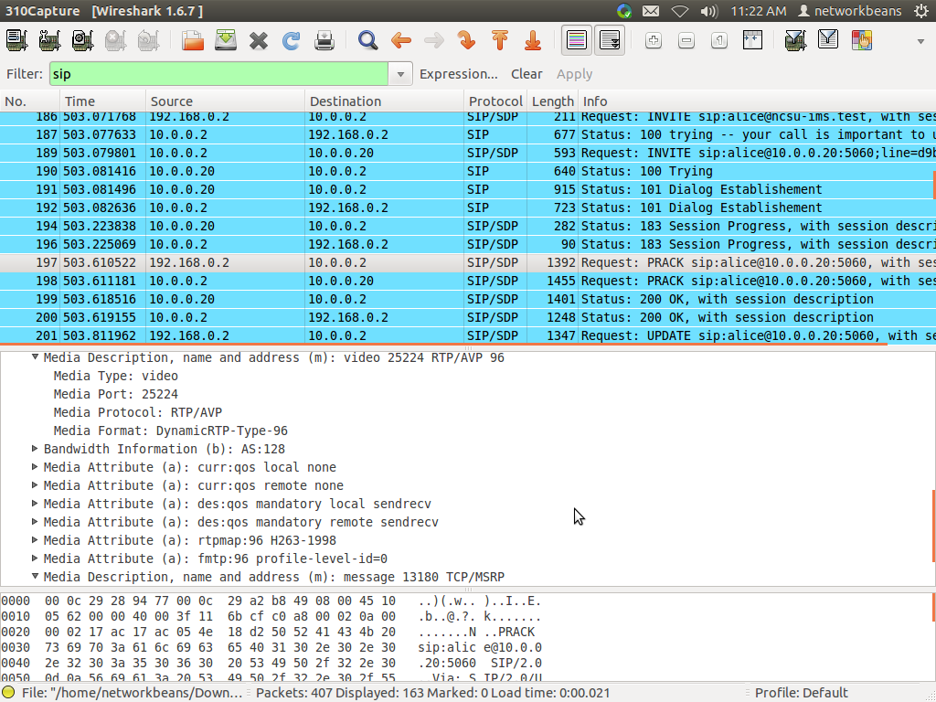

**4. Identify session progress message and identify the User-Agent ?**

User-Agent ID: UCT IMS Client with Contact info as alice@10.0.0.20:5060

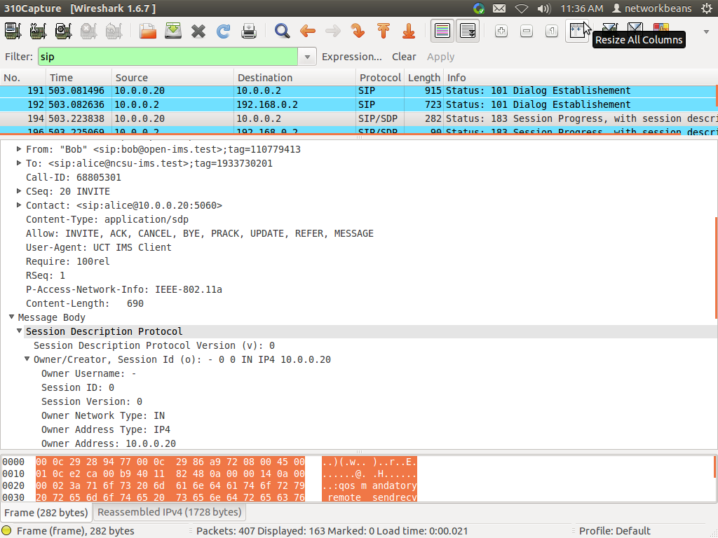

**5. Identify a Notify message and provide details of Registration information ?**

Registration information is in the screenshot below.

